Homework

- Table structures
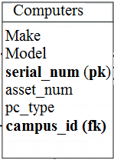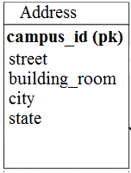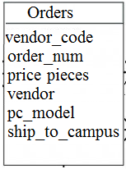

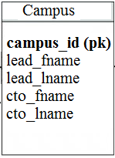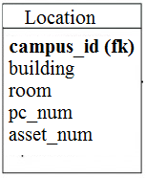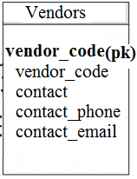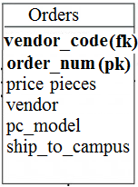

- E-R diagram

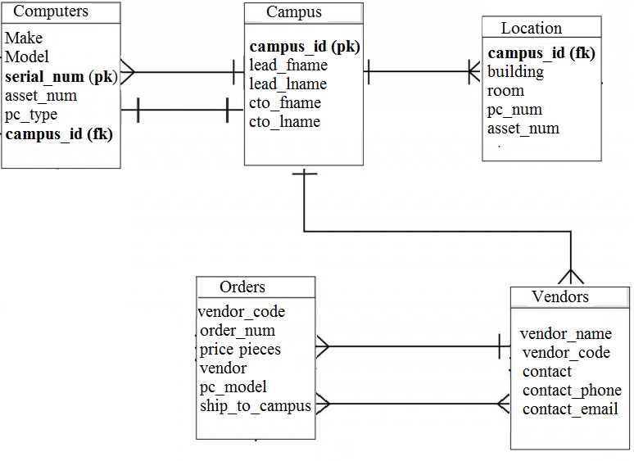

- SQL statements

CREATE DATABASE asset_inventory;
USE asset_inventory;

CREATE TABLE `address` (
`campus_id` int(3) NOT NULL PRIMARY KEY,
`street` varchar(30) NOT NULL,
`building_room` varchar(6) NOT NULL,
`city` varchar(20) NOT NULL,
`state` varchar(20) NOT NULL
);

INSERT INTO `address` (campus_id, street, building_room, city, state) VALUES
(1, '6839 Riverside Dr.', '4/222', 'Coral Springs', 'Florida'),
(2, '3985 Main St.', '8/354', 'Atlanta', 'Georgia'),
(3, '5873 76 Ave.', '10/100', 'Los Angeles', 'California'),
(4, '8833 NW 66 Lane', '15/435', 'Rockford', 'Minnesota'),
(5, '9275 SW 195 Street', '18/209', 'Boulder', 'Colorado'),
(6, '4056 Ocean Dr.', '1/200', 'Miami Beach', 'Florida');

CREATE TABLE `campus` (
`campus_id` int(3) NOT NULL PRIMARY KEY,
`lead_fname` varchar(30),
`lead_lname` varchar(30),
`cto_fname` varchar(30),
`cto_lname` varchar(30)
);

INSERT INTO `campus` (`campus_id`, `lead_fname`, `lead_lname`, `cto_fname`, `cto_lname`) VALUES
('1', 'Anthony', 'Johnson', 'Justin', 'Albrook'),
('2', 'Jonathon', 'Brooks', 'Kim', 'Skoolie'),
('3', 'Alfred', 'Johanson', 'Tim', 'Burns'),
('4', 'Zachary', 'Perez', 'Molly', 'Chang'),
('5', 'Mark', 'Sweeny', 'Lorne', 'Cleaver'),
('6', 'Richard', 'Walsh', 'Daniel', 'Brojde');

CREATE TABLE `district` (
`emp_number` int(4) NOT NULL PRIMARY KEY,
`first_name` varchar(20) NOT NULL,
`last_name` varchar(20) NOT NULL,
`title` varchar(20) NOT NULL
);

INSERT INTO `district` (`emp_number`, `first_name`, `last_name`, `title`) VALUES
('3945', 'Gerald', 'Seviers', 'Financial Officer'),
('8302', 'Daewon', 'Chao', 'Even Cooridnator'),
('2657', 'Aron', 'Somper', 'Asset Tracking'),
('7392', 'Jason', 'Newstead', 'Union Rep'),
('2945', 'Daria', 'Mazzetti', 'Union Rep'),
('7294', 'Carmen', 'Maitre', 'Event Cooridnator'),
('5934', 'Theodore', 'Boucher', 'President');

CREATE TABLE `orders` (
`vendor_code` int(4) NOT NULL,
`order_num` int(10) NULL PRIMARY KEY,
`price` varchar(10) NULL,
`pieces` int(6) NULL,
`vendor` varchar(30) NOT NULL,
`pc_model` varchar(30) NULL,
`ship_to_campus` int(3) NOT NULL,
FOREIGN KEY ship_to_campus(ship_to_campus)
REFERENCES campus(campus_id)
ON UPDATE CASCADE
ON DELETE RESTRICT
);

INSERT INTO `orders` (`vendor_code`, `order_num`, `price`, `pieces`, `vendor`, `pc_model`, `ship_to_campus`) VALUES
(2763, 3342, '$12,000', '6', 'HP', 'Z2 mini', '3'),
(5847, 8375, '$42,000', '25', 'Apple', '25.5" iMac', '1'),
(3934, 4837, '$20,000', '30', 'Lenovo', 'M93p', '2'),
(5847, 3095, '$10,000', '5', 'Apple', '27" iMac', '5'),
(6623, 7385, '$25,000', '32', 'Samsung', '24" All-In-One', '4'),
(2763, 4492, '$30,000', '6', 'HP', 'Z2 mini', '2'),
(3934, 6692, '$36,000', '30', 'Lenovo', 'M93p', '5'),
(4956, 9345, '$25,000', '62', 'Dell', 'Inspiron', '1'),
(3934, 3756, '$30,000', '20', 'Lenovo', 'X1 Carbon 6 Gen', '3'),
(7348, 4023, '$25,000', '20', 'Acer', 'Aspire XC', '4'),
(2763, NULL, NULL, NULL, 'HP', NULL, '3');

CREATE TABLE `vendors` (
`vendor_name` varchar(30) NOT NULL,
`vendor_code` int(4) NOT NULL PRIMARY KEY,
`contact` varchar(20),
`contact_phone` varchar(15),
`contact_email` varchar(40)
);

INSERT INTO `vendors` (`vendor_name`, `vendor_code`, `contact`, `contact_phone`, `contact_email`) VALUES
('HP', '2763', 'James Smithers', '984-658-9542', 'jsmithers@hp.com'),
('Apple', 5874, 'Holly Goldman', '758-486-1257', 'hgoldman2@apple.com'),
('Lenovo', 3934, 'Jesse Jones', '968-635-4598', 'jjones@lenovo.com'),
('Asus', 5883, 'Clayton Maddix', '485-684-7524', 'cmaddix@asus.com'),
('Dell', 4956, 'Zhenyi Neri', '800-657-5214', 'zneri@dell.com'),
('Gateway', 3954, 'Thomas Teig', '547-524-5491', 'tteig@gatewaypc.com'),
('Acer', 7348, 'Westly Dalton', '875-657-8546', 'wdalton@acer.com'),
('Samsung', 6623, 'Keenan Butler', '547-625-3648', 'kbutler2@samsung.com');

CREATE TABLE `computers` (
`Make` varchar(20) NOT NULL,
`Model` varchar(20) NOT NULL,
`serial_num` varchar(30) NOT NULL PRIMARY KEY,
`asset_num` int(7) NOT NULL,
`pc_type` varchar(15) NOT NULL,
`campus_id` int(3) NOT NULL,
FOREIGN KEY campus_id(campus_id)
REFERENCES campus(campus_id)
ON UPDATE CASCADE
ON DELETE RESTRICT
);

INSERT INTO `computers` (`Make`, `Model`, `serial_num`, `asset_num`, `pc_type`, `campus_id`) VALUES
('HP', 'EliteBook 830', 'XL25945', 827135, 'Laptop', 1),
('Lenovo', 'ThinkCentre M93p', 'DL928474', 82957, 'Desktop', 1),
('Samsung', 'Tab A 530', 'S34986309', 749384, 'Tablet', 3),
('Asus', 'Chromebook Flip', 'AS487309854', 7843287, 'Laptop', 2),
('Acer', 'Aspire XC', 'CD876493872', 8730297, 'Desktop', 2),
('HP', 'Z2 mini', 'H59305983', 7549284, 'Desktop', 4),
('Lenovo', 'X1 Carbon 6 Gen', 'MJ684965', 937529, 'Laptop', 4),
('Dell', 'Inspiron', 'DL5893482', 8593845, 'Desktop', 5),
('Apple', 'MacBook Air', 'C0485MHG980', '3986547', 'Laptop', 5),
('Asus', 'ZenBook', 'A583J65D3', '1984632', 'Laptop', 3),
('Gateway', 'SX Series', 'GA739J4L34', '3965723', 'Desktop', 5),
('Lenovo', 'ThinkCentre M93p', 'DL146328', '531257', 'Desktop', 1),
('Apple', 'iMac 27" Retina', 'C0485MHG452', '8632547', 'Desktop', 3),
('Dell', 'Inspiron', 'DL58958741', 8593781, 'Desktop', 5);

CREATE TABLE `location` (
`campus_id` int(3) NOT NULL,
`building` int(11) NOT NULL,
`room` int(11) NOT NULL,
`pc_num` int(40) NOT NULL,
`asset_num` int(11) NOT NULL PRIMARY KEY
);

INSERT INTO `location` (`campus_id`, `building`, `room`, `pc_num`, `asset_num`) VALUES
(1, 1, 142, 1, 827135),
(1, 2, 224, 3, 82957),
(1, 2, 224, 2, 531257),
(3, 10, 345, 1, 8632547),
(3, 10, 345, 0, 749384),
(2, 8, 277, 2, 7843287),
(3, 10, 345, 3, 1984632),
(3, 12, 122, 3, 2948573),
(4, 18, 253, 3, 937529),
(4, 20, 321, 2, 7549284),
(5, 22, 145, 1, 3965723),
(5, 22, 145, 5, 8593845),
(5, 22, 145, 3, 8593781),
(5, 24, 287, 1, 3986547);

CREATE TABLE `district_assignment` (
`assign_num` INT NOT NULL AUTO_INCREMENT PRIMARY KEY,
`campus_id` int(3) NOT NULL,
`title` varchar(20) NOT NULL,
`emp_number` int(4) NOT NULL
);

INSERT INTO `district_assignment` (`campus_id`, `title`, `emp_number`) VALUES
('1', 'Asset Tracking', '2657'),
('2', 'Asset Tracking', '2657'),
('3', 'Asset Tracking', '2657'),
('4', 'Asset Tracking', '2657'),
('5', 'Asset Tracking', '2657'),
('6', 'Asset Tracking', '2657'),
('1', 'Union Rep', '2945'),
('2', 'Union Rep', '2945'),
('3', 'Union Rep', '2945'),
('1', 'Financial Officer', '3945'),
('3', 'Financial Officer', '3945'),
('1', 'President', '5934'),
('2', 'President', '5934'),
('3', 'President', '5934'),
('4', 'President', '5934'),
('5', 'President', '5934'),
('6', 'President', '5934'),
('1', 'Event Cooridnator', '7294'),
('3', 'Event Cooridnator', '7294'),
('4', 'Union Rep', '7392'),
('5', 'Union Rep', '7392'),
('6', 'Union Rep', '7392'),
('2', 'Event Cooridnator', '8302'),
('5', 'Event Cooridnator', '8302');

